Audit một public API thực, liệt kê 5 endpoints – cho biết method, status code, headers, có RESTful hay không
API: Roblox Open Cloud API
- https://games.roblox.com/v1/games/{universeId}/favorites/count - “Get the favourite counts of a specific game.”
- Method: GET
- Status Code: 200, 400, 404.
- https://badges.roblox.com/v1/user/badges/{badgeId} – “Revokes the caller's own awarded badge instance when the badge exists on their account.”
- Method: DELETE
- Status Code: 200, 401, 403, 404
- Headers:
- https://apis.roblox.com/legacy-groups/v1/groups/{groupId}/settings - “Get/Updates the group’s description”
- Method: PUT, PATCH
- Status Code:
+ GET: 200, 400, 401, 403
+ PATCH: 200, 400, 401, 403
- https://apis.roblox.com/legacy-badges/v1/universes/{universeId}/badges - “Create a new badge”
- Method: POST
- Status Code: 200, 400, 401, 403, 404, 429
- https://friends.roblox.com/v1/my/friends/count - “Get the number of friends a user has”
- Method: GET
- Status Code: 200, 401
Headers (Response):
- ‘strict-transport-security’
- ‘x-frame-options’
- ‘roblox-machine-id’
- ‘x-envoy-attempt-count’
- ‘x-envoy-upstream-service-time’
- ‘x-terms-message’
- ‘x-ratelimit-limit’
- ‘x-ratelimit-time’
- ‘x-ratelimit-reset’
- ‘x-ingress-proxy’
- ‘alt-svc’
- ‘x-roblox-edge’
- ‘report-to’
- ‘Content-Length’
- ‘Cache-Control’
- ‘Content-Type’
- ‘Date’
- ‘Server’.
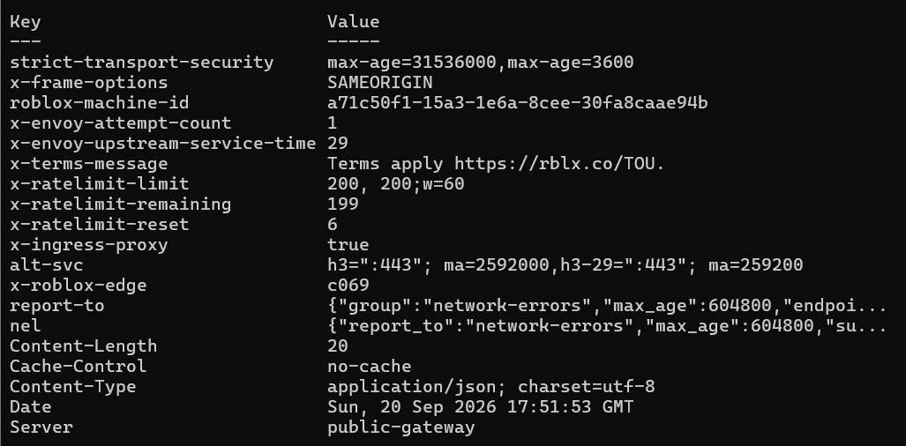
RESTful-ness: Đạt 5 yêu cầu của REST về Client-Server, Stateless, Cacheable, Uniform Interface (Identification Of Resource, Manipulation through Representation, Self-Descriptive Messages), Layered System.

